NTSAKO VALENTIAH BALOYI PROJECT 4 DECODELABS

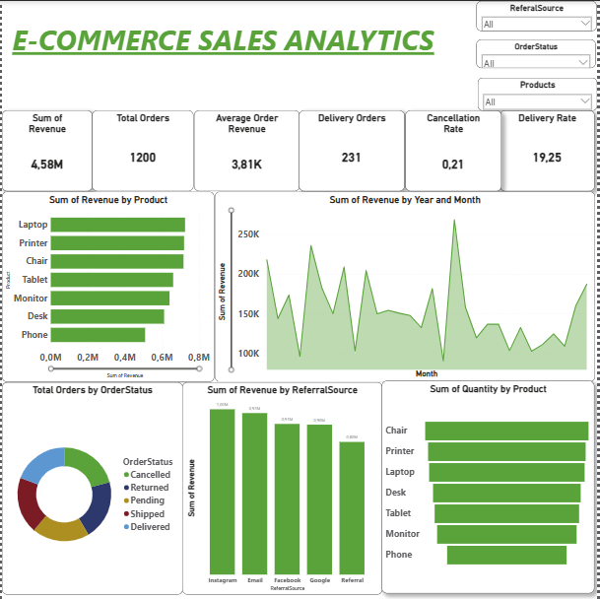

I used power bi to get this final dashboard

